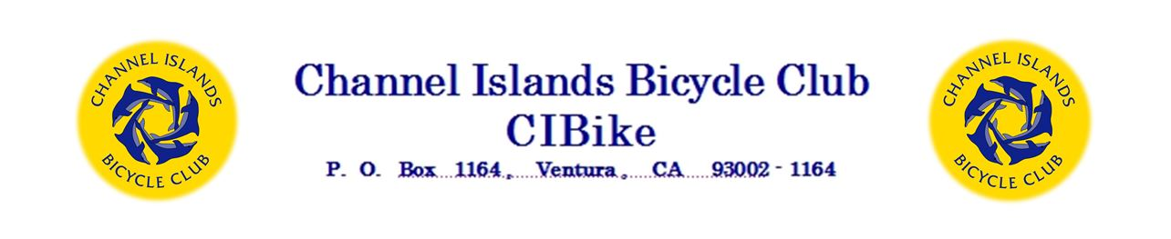
⋞ Grant Request ⋟
Date | Click here to enter a date.
Agency or Group Name | Click here to enter text
Mailing Address, Street | Click here to enter text.
City, State, Zip | Click here to enter text.
Contact Person | Click here to enter text.
Contact Person Phone Number | Click here to enter text.
Contact person email address | Click here to enter text.
Federal Tax I. D. # | Click here to enter text.
Total Amount Requested | $Click here to enter amount.

Does this request fall within the CIBike grant focus areas?

Please check the area(s) that are most closely associated with this application.
Promoting bicycling as a means of: Check applicable box(s)
☐Recreation | ☐Transportation | ☐Health | ☐Sport

This form and additional information regarding CIBike’s Grant Program are on the club website.
Email this application and attachments to: GRANTS.CIBIKE@GMAIL.COM
Or, scan and email the application and attachments to: GRANTS.CIBIKE@GMAIL.COM

or mail to:
Director of Grants
Channel Islands Bicycle Club
P.O. Box 1164
Ventura, CA 93002-1164

Successful applicants will be asked to provide a summary of the project outcomes and, if available, photographs of activities funded by the grant.

Please respond to the following questions:

- Describe in detail the project this grant will support. Be specific; including individuals or groups assigned to specific tasks and due dates for your project.
Click here to enter text.

- Describe the groups, geographic area, or populations that this project will serve.
Click here to enter text.
- Describe the estimated timeline for this project.
Click here to enter text.

- Describe the total budget for the project, and how the funding from this grant will be spent. Be as specific as possible.
Click here to enter text.

- What proportion of the total funding needed for this project does this grant represent?
Click here to enter text.
- Please describe the history of this program.
Click here to enter text.

- What specific outcomes does your organization hope to achieve with this grant? Click here to enter text.

- How will your organization publicize the CIBike grant and its results? Click here to enter text.

In addition:
Submit a copy of the IRS letter/evidence confirming your organization’s tax-exempt status. Example: 501(c)(3) or government agency tax I.D. #

Applicants may also provide:
- No more than 2 pages of supplemental narrative to support your request.
- A copy of any brochures, newsletters, media articles or other publications that describe your organization.

